|  |
| --- |
| Run your own Census Create-a-thon! |

**CREATE-A-THON TOOLKIT**

A resource from the Census Open Innovation Labs at the U.S. Census Bureau

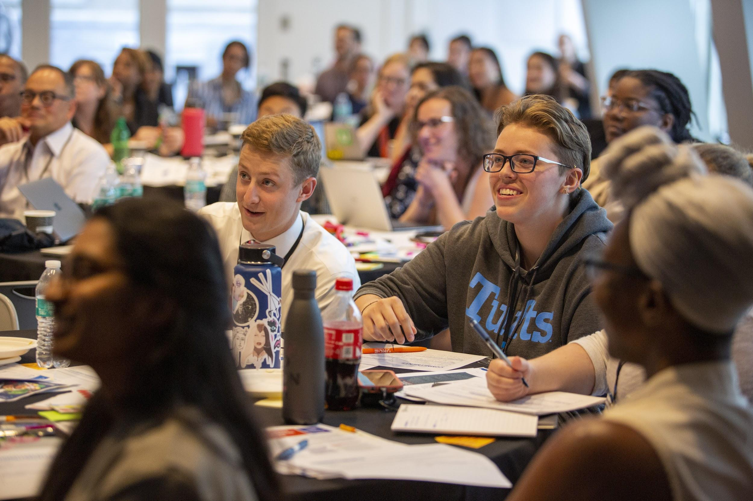

### 

|  |  |  |  |  |
| --- | --- | --- | --- | --- |
|  |  |  |  |  |
|  | Host Your Own Census Create-a-Thon Whether you’re a professional Creative, a hard-to-count community advocate, a student activist, or just fired up about Census, the following 10-week plan will get you on your way to hosting a Create-a-thon in your own community. | | |  |
|  |  |
|  |  |
|  |  |  |  |  |

### 

### 

### 

### 

### 

### 

### 

### 

### Questions? We’re here to help!

Join the [Slack Channel](https://join.slack.com/t/creativesforthecount/shared_invite/enQtNzkzNzI0MTMzNzI4LTZlMGQ0MmZhNWM2Zjk4ZDczMmQ4MjZjZTE4M2Y1N2ZjMzQ5NjY3MTkxNTczODFkYTJiNWI5NzVkYjBjZTQ5NTA) or email us at [census.accelerate@census.gov](mailto:census.accelerate@census.gov)

# **⎸Table of contents**

* About Census Create-a-thons
* Templates
* Want to host your own?
* Get inspired 10 WEEKS OUT
* Form your team 8 WEEKS OUT
* Start outreach 7 WEEKS OUT
* Get out the word 6 WEEKS OUT
* Get to know the community 5 WEEKS OUT
* Prepare for the big day 4 WEEKS OUT
* Push final outreach 2 WEEKS OUT
* Confirm details with attendees 1 WEEK OUT
* Get your head in the game and set up DAY BEFORE
* GO TIME! DAY OF
* Follow up WEEK AFTER

# **⎸About Create-a-thons**

**WHAT IS A CENSUS CREATE-A-THON?**

Many organizations leading Census outreach efforts have limited creative and/or digital capacity. Yet, as trusted voices, it is vital that their grassroots outreach efforts be amplified online to reach as many of their community members as possible. Census Create-a-thons bring together creative talent (designers, copywriters, content strategists, video-makers, etc.) with those organizations so that they can conduct more effective digital outreach, with the ultimate goal of increasing response rates among the hardest-to-count communities that they serve. Over the course of 2 - 5 informative and festive hours, participants dive into targeted briefs from local advocacy organizations, connect with a diverse group of talented people, and collaboratively generate digital media and compelling messages that spread awareness about the 2020 Census.

**THE NEXT CENSUS COUNT IS COMING IN 2020. SO WHAT’S THE BIG DEAL?**

We know the importance of voting and the impacts it has on our nation every election day. But what about the Decennial Census? The count of United States population sets our country’s trajectory for the next decade, determining congressional apportionment (the number of seats each state gets in the House of Representatives), redistricting, and how the allocation of close to $700 billion dollars is distributed annually to cities across the nation.

People of color, immigrants, LGBTQ people, people experiencing homelessness, rural communities, people with low incomes, renters, single-parent households, people with limited English proficiency, and young children are overwhelmingly undercounted in the Census. But we can help change that.

# **⎸Templates**

Use our premade templates to quickly start planning and developing materials for your Create-a-thon.

If you’re unable to access Google Docs,

download Powerpoint and PDF versions of these materials [**here**](https://opportunity.census.gov/resources/CreativesForTheCount_Toolkit.zip).

|  |  |
| --- | --- |
| Template | Description |
| [Checklists](https://docs.google.com/document/d/1BHU_DyTuuyJp-Mw1lGjN1hQci1d2Z4XtOH4Uhwj-4OM/edit?usp=sharing) | A collection of checklists to stay on top of your event planning. |
| [Run of Show](https://docs.google.com/document/d/1BpACFZGJzNfCmX4WBPcEWZDXXTpclcx5ReuWkMsVbVk/edit?usp=sharing) | A minute-to-minute sequence for running the live event for you and your team. |
| [Starter Deck](https://docs.google.com/presentation/d/1Hp61Z5y56klmdIn9_lkszmysffwOGyBY08gu2SahYII/edit?usp=sharing) | Slides for kicking off, executing, and closing out the event. Delete what you don’t need and make it your own! |
| [Emails](https://docs.google.com/document/d/1ltRcBkWsMaBhXFd_bifWMbvbWBDaThgE0JWqglIeO2U/edit?usp=sharing) | Example language for email communications around the event. |
| [Persona Worksheet](https://docs.google.com/presentation/d/17heHxEhNSF3jH_tTxU4K_aULYQ2q_nB9dVk1lLOk6_o/edit?usp=sharing) | Participants can use these worksheets to develop a persona, a representation of your target audience. |
| [Commitment Cards](https://docs.google.com/presentation/d/1R-vB88WEdJ9HYsLnitmzS3erRzny1_GbOw1UTWwEqc0/edit?usp=sharing) | Use these to collect feedback and commitments. Print enough copies for all participants to fill out at the end of your event. |
| [Signs](https://docs.google.com/presentation/d/1mR39ZTJ6_rT-eWgvYRnprtOSHJlXP2tl8iFvjvxtiJc/edit?usp=sharing) | Use these to label team tables, bathrooms, etc. |
|  |  |

# **⎸Want to host your own?**

Awesome! Create-a-thons are being hosted by Census staffers, advocacy groups, community organizers, students, and concerned citizens across the country.

**Interested in hosting a Create-a-thon and need some support?** If you haven’t already, [start by filling out this form to let our team know you’re interested.](https://coil992463.typeform.com/to/N2daiF)

# 

# **⎸Get inspired** 10 WEEKS OUT

Check out the bank of content generated from Create-a-thons hosted across the country. Get familiar with the types of content created — from animated Gifs to social banners to videos to comics — and all of the different messages that can motivate communities to get out the count.

<https://www.creativesforthecount.org/>

# **⎸Form your team** 8 WEEKS OUT

Decide which hard-to-count community / communities you’ll focus on, and start planning. Venue? Partners? Date and time? Volunteers? Creating an event page? Who’s responsible for what? Will this be a 2-hour Create-a-thon or a half-day? Who will be your facilitator?

We’ve pulled together [**a checklist**](https://docs.google.com/document/d/1BHU_DyTuuyJp-Mw1lGjN1hQci1d2Z4XtOH4Uhwj-4OM/edit?usp=sharing) with everything you need to know to get into planning mode. It is your new best friend for all things Create-a-thon planning.

# **⎸Start outreach** 7 WEEKS OUT

Caffeine and food work wonders for Create-a-thon productivity. Spend some time this week getting the conversation going with local vendors to supply some or all of the below:

Required:

* Meals and/or snacks (depending on length of event)
* Coffee and tea!
* Post-its, pens, and the other supplies you need - refer to the checklist for the full list of supplies needed

Optional:

* Refreshments if you wish to host a reception following your Create-a-thon
* Prizes for teams that generate the strongest content
* Goodie bags or other thank you gifts for attending
* Live music as participants enter or at the conclusion

# **⎸Get out the word** 6 WEEKS OUT

Just because you build it doesn’t mean people will come — so make sure you budget time to get out the word. Spend some time researching which networks to invite, so that there’s a balance between creatives and those comfortable making content, with those working closely with the hard to count community your event is focused on (*sometimes* those groups are one and the same, but not always!). [**More ideas for outreach on the event checklist!**](https://docs.google.com/document/d/1BHU_DyTuuyJp-Mw1lGjN1hQci1d2Z4XtOH4Uhwj-4OM/edit#)

Once you have guests confirmed, keep them engaged and get them event-ready by sending emails two weeks, one week and one day ahead of the event.

See our [email templates to save the date, confirm attendees, and follow up](https://docs.google.com/document/d/1ltRcBkWsMaBhXFd_bifWMbvbWBDaThgE0JWqglIeO2U/edit).

# **⎸Get to know the community** 5 WEEKS OUT

While you know which hard-to-count community (or communities) you’re focused on, do you know generally where people within this community access their media? Which messages will be most motivating? What some of the countless identities and diverse experiences that exist within this hard to count group?

We recommend spending time researching your hard to count community, and creating “personas,” a term we borrowed from a discipline called human-centered design. A persona is an archetypal person — either real or fictitious — that represents some of the key dynamics your hard-to-count group, and helps ground ideation in lived human experiences.

* + If you’re not sure, ask. Here are [interview questions](https://docs.google.com/document/d/1cQJPQitfSQFeGuB8CBm5homyktEY2le1FAGLZAXXwmk/edit?usp=sharing) that we’ve used to guide conversations with organizations representing hard-to-count communities.
  + [Use this template](https://docs.google.com/presentation/d/17heHxEhNSF3jH_tTxU4K_aULYQ2q_nB9dVk1lLOk6_o/edit?usp=sharing) to create personas ahead of the event, or hand these out and invite individual groups to write them up, with people who can personally identify with the hard-to-count group in discussion.
  + If you or the interviewee do not identify as a member of the hard-to-count group for whom you’ve developed a persona, it is critical that someone from that group review it prior to the event to ensure cultural appropriateness.

# **⎸Prepare for the big day** 4 WEEKS OUT

We’ve done the legwork of preparing materials for your day of — now you just have to customize based on the length of time you have, and the audience you’re working with. Feel free to make a copy of these documents on Google Drive to use for your events.

* + [Different top-line agenda depending on the amount of time you have](https://docs.google.com/document/d/1BHU_DyTuuyJp-Mw1lGjN1hQci1d2Z4XtOH4Uhwj-4OM/edit#) —(in checklist).
  + A plan for how your content will be uploaded and displayed — either through a Slack Channel, [through our Google Drive link](http://bit.ly/census2020workshop), or emailed directly to the facilitator.
  + [A customizable presentation for the day of your event.](https://docs.google.com/presentation/d/1L0jH9HV1A24UUNiQzOIyxGkV_dhgDhIurlprHzzGizk/edit?usp=sharing)
  + [A run of show template, so that your team can keep track of who is saying what, and everything happening behind the scenes](https://docs.google.com/document/d/1BpACFZGJzNfCmX4WBPcEWZDXXTpclcx5ReuWkMsVbVk/edit)**.** We recommend running through this as a full team.
  + A bunch of resources you might consider printing out and sharing with participants. See below!

|  |
| --- |
| Extra Resources to Share at your Create-a-thon |
| Getting familiar with Census 101, and hand-outs to share at your Create-a-thon:   * [Census 101: What you Need to Know Fact Sheet in English](https://www.census.gov/library/fact-sheets/2019/dec/census101.html) * [Información básica sobre el censo: Lo que usted necesita saber](https://www.census.gov/library/fact-sheets/2019/dec/census101-spanish.html) * [How the 2020 Census will invite everyone to respond](https://www.census.gov/library/fact-sheets/2019/dec/2020-invites-everyone.html) * [Cómo el Censo del 2020 invitará a todos a responder](https://www.census.gov/library/fact-sheets/2019/dec/2020-invites-everyone-spanish.html) * [Download and share additional fact sheets](https://www.census.gov/library/fact-sheets.html) |
| Understanding barriers and motivations of different hard-to-count groups:  The Census Barriers, Attitudes, and Motivators Study (CBAMS) is a nationwide survey of 50,000 households that covers a range of topics related to census participation and completion. Results allow the Census Bureau to understand and compare barriers, attitudes, and motivators across demographic subgroups such as Asian, Black, Hispanic, White, and, given sufficient sample size, additional groups like income and education levels.   * [Census Barriers, Attitudes, and Motivators Study (CBAMS)](https://www.census.gov/programs-surveys/decennial-census/2020-census/research-testing/communications-research/2020_cbams.html) * [Researching the Attitudes of Households Reporting Young Children](https://www.census.gov/programs-surveys/decennial-census/2020-census/planning-management/final-analysis/2020-report-cbams-attitudes-reporting-children.html) (kids under 5) |
| Videos to screen at your Create-a-thon:   * [Shape Your Future: The 2020 Census](https://www.youtube.com/watch?v=LXJz7ZfzAuM) *(U.S. Census Bureau)* * [The Census is about Power and Money](https://www.youtube.com/watch?v=HMaaH6Suf98) *(Rock the Vote)* |
| Other resources that might come in handy:   * [Language guides and translations of commonly used terms in the 2020 Census](https://www.census.gov/programs-surveys/decennial-census/2020-census/planning-management/language-resources/language-glossaries.html) |

# **⎸Push final outreach** 2 WEEKS OUT

Oftentimes people only commit to things within the two weeks prior, so don’t panic if attendance seems low up to this point. But do spend some time this week doing another blast of outreach. Take a look at your RSVP list and see what types of disciplines are missing. Need more creatives, or more trusted messengers? Put your focus there. Create-a-thons have been as small as 30 participants and as big as 120 — so depending on your venue capacity, you will want to set a target attendee goal. We’re generally in the more the merrier camp — and the more content —but it’s up to you where to set your target attendee goal.

# **⎸Confirm details with attendees** 1 WEEK OUT

Send a final confirmation email to your attendees. Take advantage of [our email templates](https://docs.google.com/document/d/1ltRcBkWsMaBhXFd_bifWMbvbWBDaThgE0JWqglIeO2U/edit?usp=sharing) to guide your outreach.

Any questions as you’re doing the final stretch prep? Does your facilitator want to do a practice run? Our team is here! Email us at [census.accelerate@census.gov](mailto:census.accelerate@census.gov).

# **⎸Get your head in the game** DAY BEFORE

You’ve picked up your supplies from the create-a-thon Checklist. Your day before confirmation is sent. Don’t forget to get all your print materials ready, including:

* + - Your Splash attendee list for check-in
    - [Commitment Cards](https://drive.google.com/open?id=1rm8WYitgfIYYT5oENIGtcEi9LdrIHLY_Hz0J9dilwpI)
    - [Census 101 Info Sheets](https://drive.google.com/open?id=1XFhT0CkC8KOS8GwtnYwUsB6DJQdR_0as)
    - Distribute fact sheets about reaching your hard to count community

# **⎸Go!** DAY OF

Go for it! And remember, have fun!

As a reminder, these are the file types all assets need to be created in order to live on [creativesforthecount.org](https://www.creativesforthecount.org/), so urge your attendees to create files in these formats.

For static files:

* .jpeg
* .jpg
* .png
* .gif

For editable files:

* .eps
* .psd
* .ai
* .indd
* .sketch

# **⎸Follow up** 1 DAY AFTER

Keep in mind, everything created during this event is considered Open Source Content and can be copied or modified freely, without asking for permission. In the fight against mis- and disinformation, accuracy is key!

Please double-check all facts, and if quoting someone, please use attribution including date, name, and source. When in doubt, Census.gov is your first stop for fact-checking.

When your content is ready, you can upload it directly to the Rock The Vote site, [creativesforthecount.org](https://www.creativesforthecount.org/)

### **Job well done!**

Don’t forget to share photos with our team at [census.accelerate@census.gov](mailto:census.accelerate@census.gov).